 | ASHOKRAO MANE POLYTECHNIC, VATHAR.
 | Department: Automobile |  | Academic Year: 2020-21
 | YEZAKI SELECTED STUDENT LIST
Sr.No. | Name of Student | Photo
1 | BHAVESH VIJAY PATIL  Associate Trainee  Package -2,10,000/- Per Year | 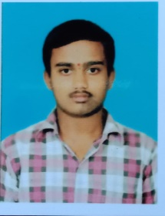
2 | ROHIT SANJAY LOKARE  Associate Trainee  Package -2,10,000/- Per Year
3 | VISHAL SANJAY PATIL  Associate Trainee  Package -2,10,000/- Per Year | 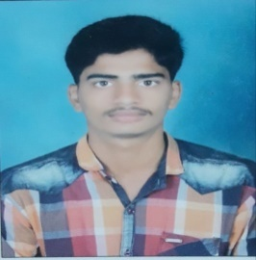
4 | AVINASH KASHINAT GURAV  Associate Trainee  Package -2,10,000/- Per Year | 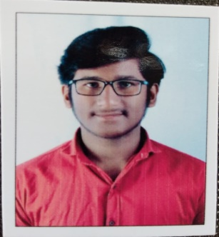
5 | ROHIT JANGONDA PATIL  Associate Trainee  Package -2,10,000/- Per Year | 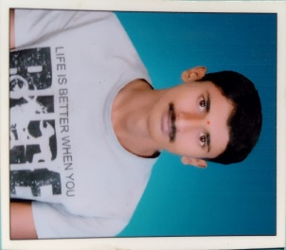
6 | PATIL SAHIL BHRATESH  Associate Trainee  Package -2,10,000/- Per Year | 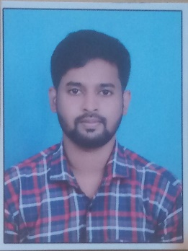
7 | HARSHVARDHA SHANTINATH PATIL  Associate Trainee  Package -2,10,000/- Per Year | 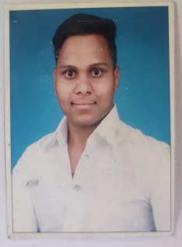
8 | SHUBHAM SARJERAO BACHATE  Associate Trainee  Package -2,10,000/- Per Year
9 | ASHUTOSH ANIL PATIL  Associate Trainee  Package -2,10,000/- Per Year | 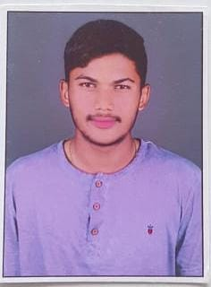
10 | YASIN ISMAIL MULLA  Associate Trainee  Package -2,10,000/- Per Year | 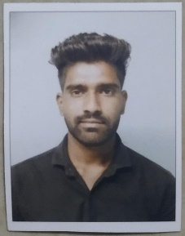
11 | SHUBHAM SHRISHAIL SWAMI  Associate Trainee  Package -2,10,000/- Per Year | 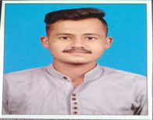
12 | SHUBHAM DHANANJAY PATIL  Associate Trainee  Package -2,10,000/- Per Year | 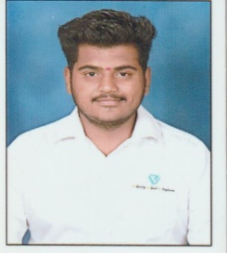
13 | VISHAL MAHADEV THERGAVE  Associate Trainee  Package -2,10,000/- Per Year | 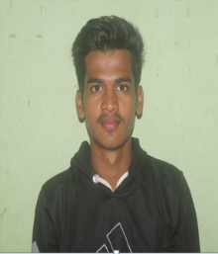
14 | PRATIK SUNIL POWAR  Associate Trainee  Package -2,10,000/- Per Year
15 | SOURABH RAMGONDA PARAJ  Associate Trainee  Package -2,10,000/- Per Year | 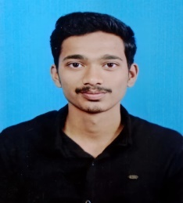
16 | ADITYA RAVINDRA BHAGWAT  Associate Trainee  Package -2,10,000/- Per Year | 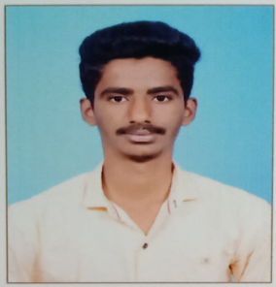
17 | PRATIK BAJIRAO GAVADE  Associate Trainee  Package -2,10,000/- Per Year | 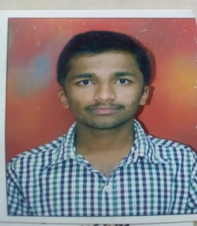
18 | SHREYAS DIWANJI MANE  Associate Trainee  Package -2,10,000/- Per Year | 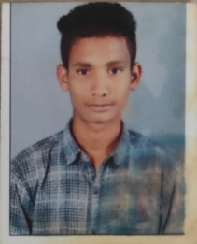
19 | ANUJ AVDHUT GHODKE  Associate Trainee  Package -2,10,000/- Per Year | 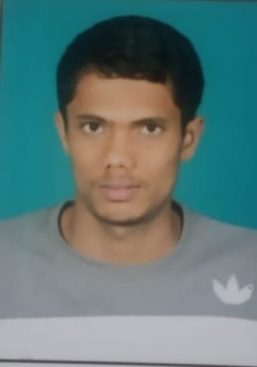
20 | CHAVAN SHIVRAJ UTTAM  Associate Trainee  Package -2,10,000/- Per Year | 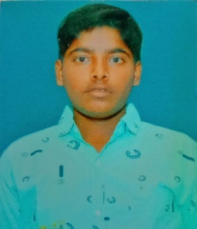
21 | PADMA SURESH GADEKAR  Associate Trainee  Package -2,10,000/- Per Year
22 | BHUSHAN RANGRAO PATIL  Associate Trainee  Package -2,10,000/- Per Year | 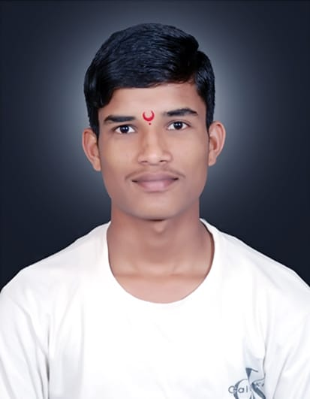
23 | SAHIL HARUN JAMADAR  Associate Trainee  Package -2,10,000/- Per Year | 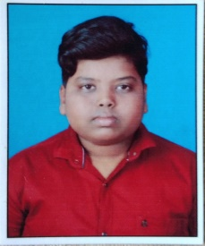
24 | ANIKET ASHOK PADLKAR  Associate Trainee  Package -2,10,000/- Per Year | 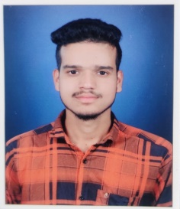
25 | VISHAMBHAR SUHAS GHODKE  Associate Trainee  Package -2,10,000/- Per Year | 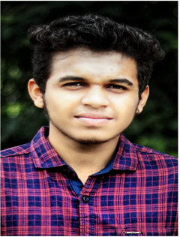
26 | BHAVIKA DAATTARY TADE  Associate Trainee  Package -2,10,000/- Per Year
27 | ABHISHEK UDAY DHOKLE  Associate Trainee  Package -2,10,000/- Per Year | 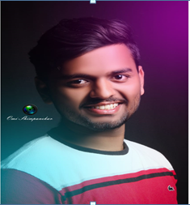
28 | TEJAS TANAJI CHOUGULE  Associate Trainee  Package -2,10,000/- Per Year
29 | KARAN VIJAY NANDANWAR  Associate Trainee  Package -2,10,000/- Per Year | 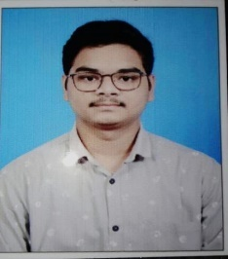
30 | PRIYANKA MANE  Associate Trainee  Package -2,10,000/- Per Year | 