YAZAKI INDIA PVT. LTD. PUNE- MECHANICAL ENGINEERING DEPARTMENT, AMP, VATHAR
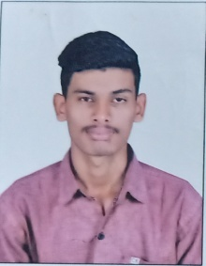 | 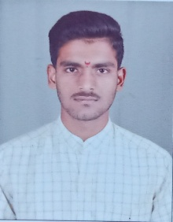 | 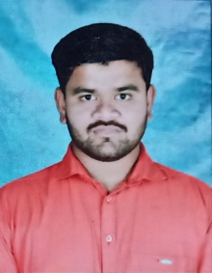 | 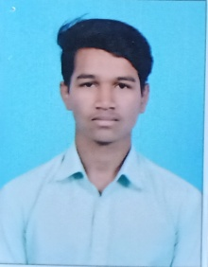 | 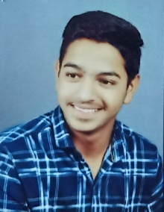 | 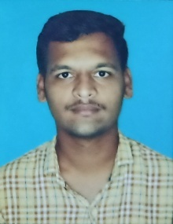
KAMBLE ROHAN MAHADEV | KHOT AMEY SHIVAJI | KHARKANDE VINAYAK SANJAY | PATIL PRATHMESH VAIBHAV | SHINDE SURAJ PRAKASH | PATIL SATYAJIT MOHAN
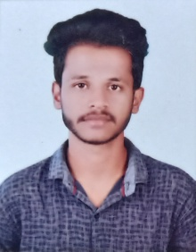 | 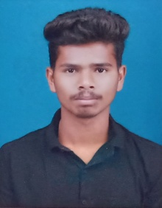 | 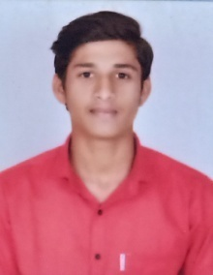 | 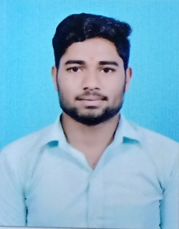 | 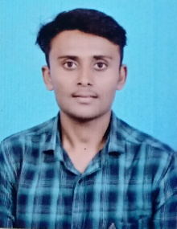 | 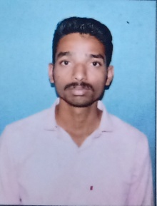
MAGADUM SWANAND VISHNU | KAMBLE ANIKET BALASAHEB | BAVADE SHUBHAM VASANT | KHADE AKASH DATTATRAY | KARANDE ABHISHEK ANIL | PANDAV ROHAN RAVINDRA
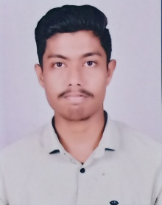 | 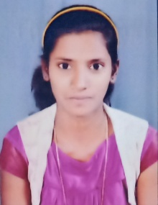 | 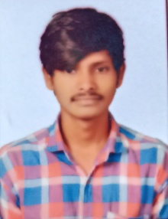 | 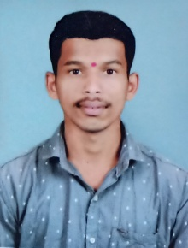 | 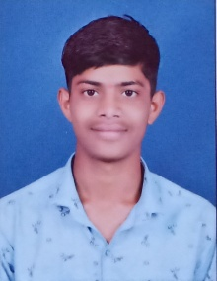 | 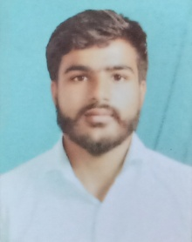
KAKADE PRATIKRAJ SHRIMANT | KAMBLE PALLAVI BALASO | JADHAV PRUTHVIRAJ ANANADA | MALAKAR PRATHAMESH SHANKAR | PATIL OMKAR SANJAY | ADAKE RUSHIKESH SHASHIKANT
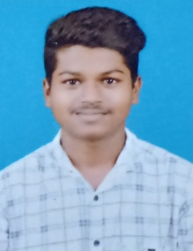 | 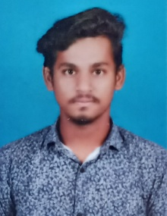 | 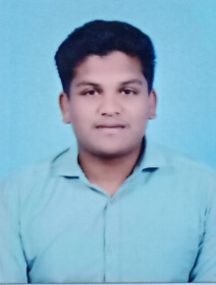 | 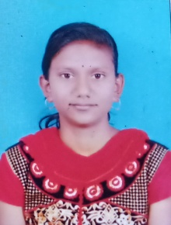 | 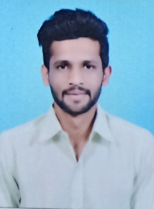 | 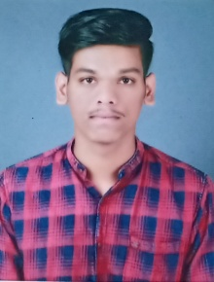
KUMBHAR PRAMOD PARSHURAM | THORAT OMKAR MAHADEV | CHAVAN VIPUL VIJAY | SALGAR AARTI ANNASAHEB | MALI ROHAN ASHOK | JADHAV VAIBHAV SAMBHAJI
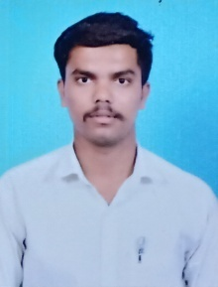 | 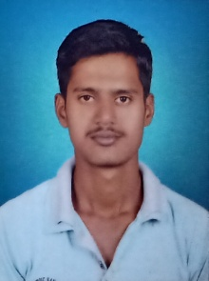 | 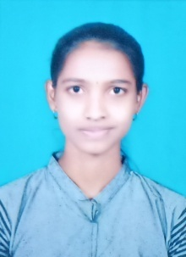 | 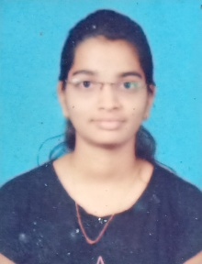 | 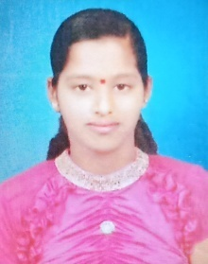 | 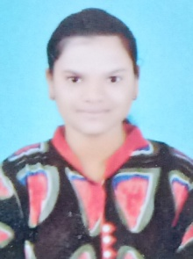
PATIL YOGESH RAJARAM | PATEL SHAHABAZ HAROON | SALUNKHE HARSHADA KISAN | PATIL RUTUJA ANIL | PAWAR VISHVANKITA RAMCHANDRA | SAVANT ANKITA CHANDRAKANT
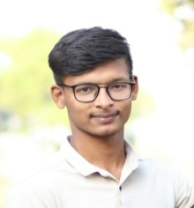 | 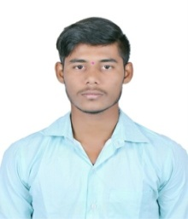 | 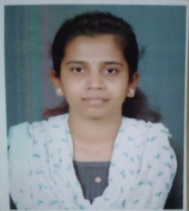 |  | Mechanical Engineering Dept.  Associate Trainee  Package -2,10,000/- per Year
VELHAL RUSHIKESH GIRIDHAR | PATIL DIPAK BALKRUSHNA | PATIL PRIYANKA MAHESH

