Swanand Vishnu Magadum- Mechanical  Diploma Apprentice Trainee  Package -1,32,000/- Per Year | 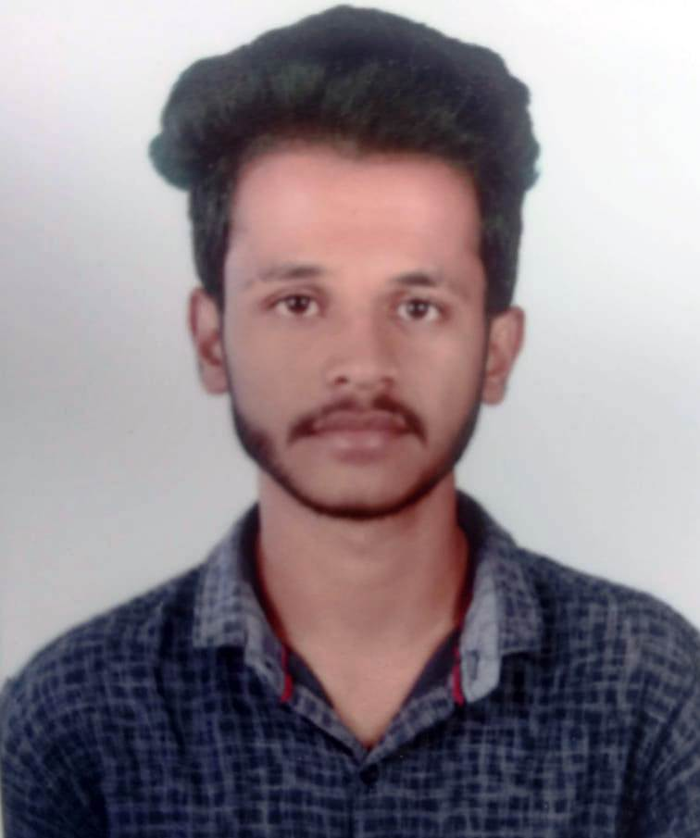
Lavate Shubham Shahaji- Mechanical
Diploma Apprentice Trainee
Package -1,32,000/- Per Year

Pratik Shivaji Magdum- Mechanical
Diploma Apprentice Trainee

Package -1,32,000/- Per Year

Abhishek Anil Karande- Mechanical
Diploma Apprentice Trainee

Package -1,32,000/- Per Year

Satyajit Mohan Patil –Mechanical
Diploma Apprentice Trainee

Package -1,32,000/- Per Year

