Aditya Ravindra Bhagwat-Automobile
Diploma Engineer Trainee
Package -1,38,000/- Per Year

Dipak Balkrushna Patil- Mech
Diploma Engineer Trainee
Package -1,38,000/- Per Year

Priyanka Mahesh Patil – Mechanical
Diploma Engineer Trainee

Package -1,38,000/- Per Year
Kiran Vijay Nandanwar- Automobile  Diploma Engineer Trainee  Package -1,38,000/- Per Year | 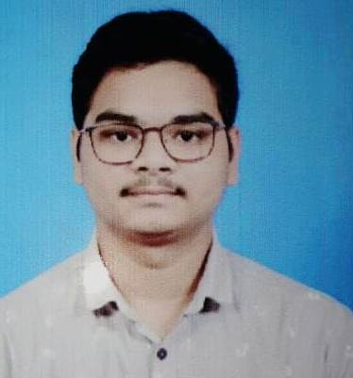
Swanand Vishnu Magadum- Mechanical  Diploma Engineer Trainee  Package -1,38,000/- Per Year | 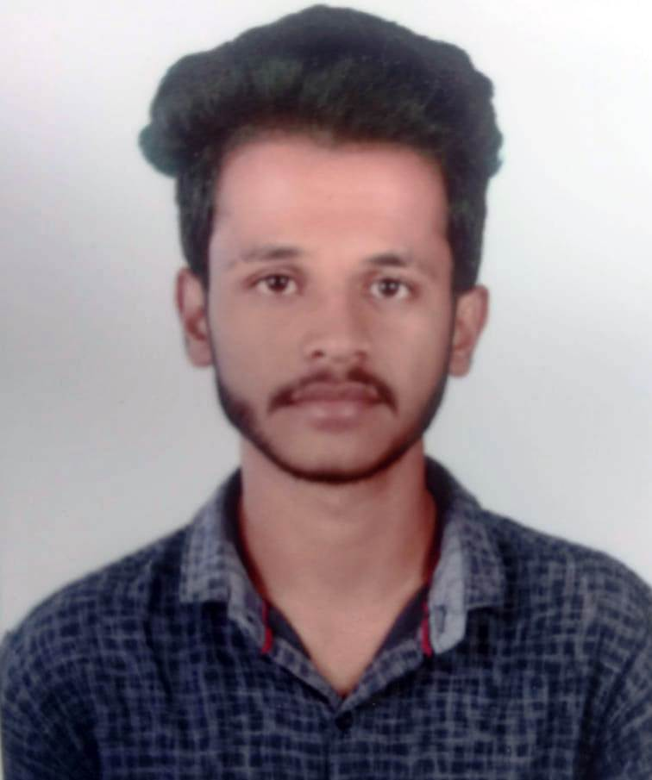

Ranjit Tanaji Patil- Mechanical
Diploma Engineer Trainee

Package -1,38,000/- Per Year

Bhavesh Vijay Patil –Automobile
Diploma Engineer Trainee

Package -1,38,000/- Per Year

Prakash Dasharath Mestri-Mechanical
Diploma Engineer Trainee

Package -1,38,000/- Per Year

