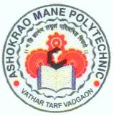 | Shri Balasaheb Mane Shikshan Prasarak Mandal’s,  ASHOKRAO MANE POLYTECHNIC  Vathar Tarf Vadgaon, Tal. Hatkanangle, Dist. Kolhapur-416 112(Maharashtra)
Department of Mechanical Engineering
(NBA Accredited, ISO Certified, Excellent remark by MSBTE)
 | Academic Year : 2023-2024 | Page: 01 of 01
 | Semester: | Date:
 | Faculty Profile

Maharashtra State Board of Technical Education D-16

Faculty Name: - | Mr. Lambe Sudheer Baburao | 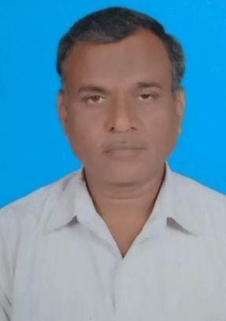
Faculty designation: - | Lecturer
Highest Qualification: - | B.E. Mechanical
Experience Teaching Years: - | 18 Years
Experience Industrial: - | 8 Year
Additional information: - | M.E .(Production)App.
Date of appointment: - | 07/07/2008
Subjects Taught: -Mechanical Engineering Materials(22343), Manufacturing Technology (312313), Industrial Fluid Power(12242), Advanced Manufacturing Processes(22563), Production Processes(12091), Machine Design(12241), Production Technology (12243), Management (12219), Advanced Manufacturing Processes (17527), Behavioral Science (17075), Project
(17090) ,Management (17601).

Worked As : External academic monitoring committee member, MSBTE paper setter, MSBTE examination controller, External practical/oral examiner.
Training programs attended in last 2 Years: -
- Faculty development program on ‘Opportunities and challenges in outcome based education’ held during 29/01/2024 to 02/02/2024 organized by Automobile Engineering Department, Ashokrao mane polytechnic.
- ISTE approved faculty development program during 18/12/2023 to 20/12/2023 on Advancement in E-Transportation organized by electrical engineering department, Ashokrao Mane Polytechnic.
- DBATU sponsored one week short term training program on ‘Design of Experiment and Optimization’ from 11 Dec 2023 to 16 Dec 2023.
- Faculty development program on ‘Advanced Trends in Mechanical Engineering’ held during 27/12/2023 to 29/12/2023 organized by Mechanical Engineering Department, Ashokrao mane polytechnic.
Conference/ Seminars/Workshops attended: - Paper published: -
Research /Development: - Projects Undertaken:

