Principal’s Desk

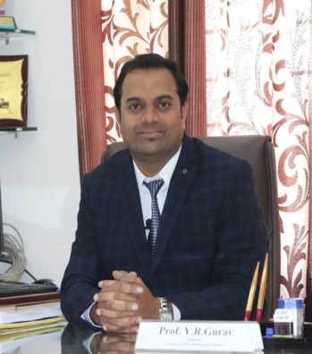
Prof. Y. R. Gurav
It is a great pleasure for me to welcome you to Ashokrao Mane Polytechnic. In this very dynamic and competitive educational environment, the college is in the process of providing quality education and re-positionitself to meet the challenges.Meeting and measuring up to the emerging challenges is the prime function of today's students. To do this, it requires keen perception, flexibilityand the ability to merge theories into action plans. We believe in providing students with hands-on training that will further hone their technical skills with soft skills. We believe in giving our students the competitive advantage in the business world, by encouraging them to be inquisitive and make informed choices. Apart from the prescribed curriculum by the MSBTE, our college structures customized special programmes based on specific requirements of the industry with a focus on priorities. Periodic quality audits are
conducted to ensure effective teaching, class room management, efficient documentation and judicious review of teaching learning process. Ashokrao Mane Group of Institutions is committed to play a key role in creating an ambience for nurturing the leaders of tomorrow. In doing so, we hope to make significant contributions to the development of the country and improvement in the quality of life of its citizens. I welcome you to explore our College as we commit ourselves to reach even greater heights.
HOD’s Desk

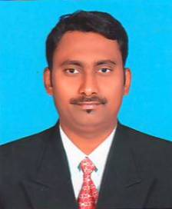
Mr. S. A. Lakade
“We feel very fortunate to have someone of him credentials & background leading our teaching & learning department.”
This newsletter has been named to pay tribute to his contribution to the field of Science &Engineering. This newsletter is an attempt to show case the department profile and its technical and non-technical activities for overall growth of students. It is an attempt
to encourage both faculty and students to publish their technical work and share information about their extra-curricular activities. I thank our Principal and the management for helping and guiding me in bringing out this newsletter. I also thank my students and colleagues for their help and support during this work. “The best leader is the one who has sense enough to pick good men to do what he wants done, and the self-restraint to keep from meddling with them while they do it.” Department is committed to fulfill vision and follow the mission for same.
We are now ready for National Board Accreditation (NBA).
I am wishing a best luck to all my students and my faculty members to their bright career, and thanking for their efforts towards department and institute.
VISION:
To be well recognized department in technology to meet the growing needs of the industry and society.
MISSION:
- Imparting quality education through a well-designed curriculumwhich improves basic and disciplinary knowledge of the subject.
- To train the students to design, develop and test world class software systems.
- To inculcate the spirit of analysis, teamwork, innovation and professionalism among the students.
- To train students with hand and soft skills for their future jobs, higher studies and to be an entrepreneur.

Editor’s Desk

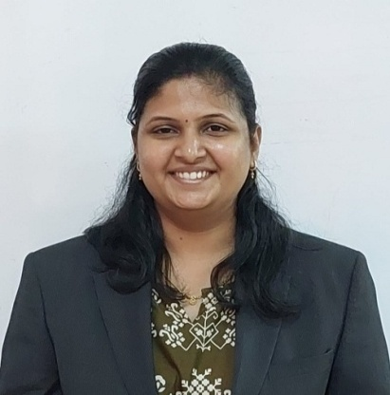
Ms. S. P. Nikam
It gives me an immense pleasure torelease this News Letter for Departmentof Computer Engineering year 2022-2023 It’s an honor for me to highlight the achievement of department.
Student’s Editorial

It’s an honor for us to be the student editor of the Newsletter team.We takesthis opportunity to thank committee members and all staff members of the department for their help&support in publishing this Newsletter.
Miss. Shrusti Patil (TY CO)
Miss. Jyoti Patil (TY CO)

OUr TOPPERS
Third Year Toppers
1)Mr. Sutar Pranav S. (93.00%)
2)Mr. Mali Abhishek Pundalik.(88.56%)
3) Mr. Patil Aryan R.(88.44%)

Second Year Toppers
1)Mr. Dange Diptesh D. (91.87%)
2)Mr. Patil Vishal P.(89.60%)
3) Miss. Tiwari Niharika S.(89.47%)

Events Organized

“EXPERT LECTURE ON PYTHON”
Ashokrao Mane Polytechnic and Department of Computer Engineering, had organized expert lecture of “Python” dated on 29/03/2023.
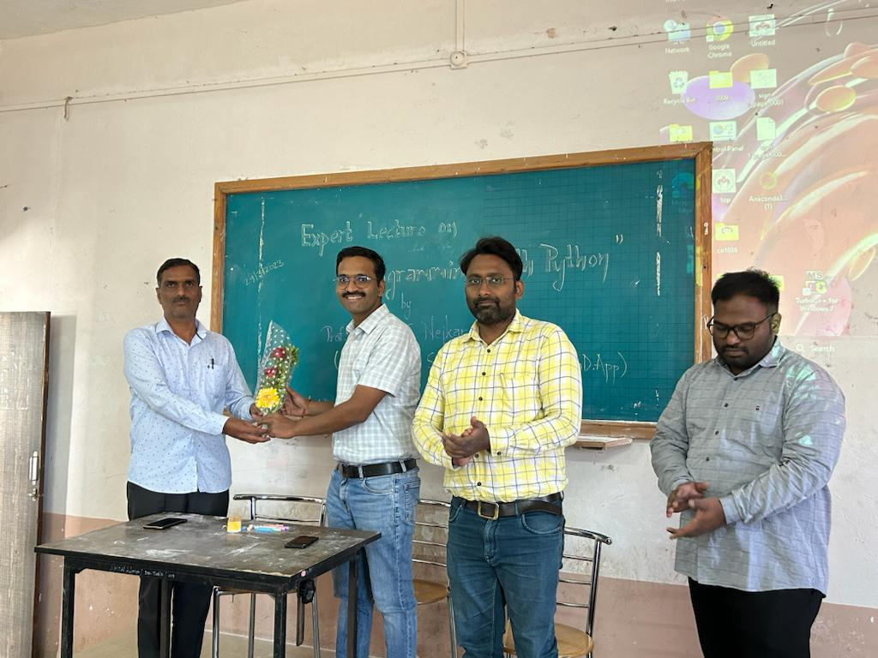

First, we inaugurated the program and done the felicitation of expert by HOD.
This expert lecture is delivered by Mr..Rahul Nejkar(HOD CSE Department, Sanjeevan Engineering & Technology Institute,Panhala).
This expert lecture had organized according to curriculum of M.S.B.T.E. This expert lecture as very helpful to students to improve their knowledge about Career Development
also important for their academic point of
view. Students took participation very interestingly and made very good interaction with expert.
anyone’s life. The celebration marks lot of respect for the Gurus.

