Principal’s Desk

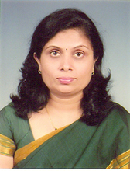
Dr. A. A. Miraje
It is a great pleasure for me to welcome you to Ashokrao Mane Polytechnic. In this very dynamic and competitive educational environment, the college is in the process of providing quality education and re-position itself to meet the challenges. Meeting and measuring up to the emerging challenges is the prime function of today's students. To do this, it requires keen perception, flexibility and the ability to merge theories into action plans. We believe in providing students with hands-on training that will further hone their technical skills with soft skills. We believe in giving our students the competitive advantage in the business world, by encouraging them to be inquisitive and make informed choices. Apart from the prescribed curriculum by the MSBTE, our college structures customized special programmes based on specific requirements of the industry with a focus on priorities. Periodic quality audits are conducted to ensure effective teaching, class room management, efficient documentation and judicious review of teaching learning process. Ashokrao Mane Group of Institutions is committed to play a key role in creating an ambience for nurturing the leaders of tomorrow. In doing so, we hope to make significant contributions to the development of the country and improvement in the quality of life of its citizens.I welcome you to explore our College as we commit ourselves to reach even greater heights.
HOD’s Desk

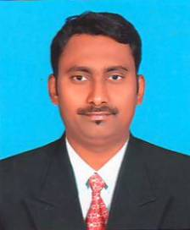
Mr. S. A. Lakade
“We feel very fortunate to have someone of him credentials & background leading our teaching & learning department.”
This newsletter has been named to pay tribute to his contribution to the field of Science & Engineering. This newsletter is an attempt to show case the department profile and its technical and non-technical activities for overall growth of students. It is an attempt
to encourage both faculty and students to publish their technical work and share information about their extra-curricular activities. I thank our Principal and the management for helping and guiding me in bringing out this newsletter. I also thank my students and colleagues for their help and support during this work. “The best leader is the one who has sense enough to pick good men to do what he wants done, and the self-restraint to keep from meddling with them while they do it.” Department is committed to fulfill vision and follow the mission for same.
We are now ready for National Board Accreditation (NBA).
I am wishing a best luck to all my students and my faculty members to their bright career, and thanking for their efforts towards department and institute.
VISION:
To be well recognized department in technology to meet the growing needs of the industry and society.
MISSION:
- Imparting quality education through a well-designed curriculum which improves basic and disciplinary knowledge of the subject.
- To train the students to design, develop and test world class software systems.
- To inculcate the spirit of analysis, teamwork, innovation and professionalism among the students.
- To train students with hand and soft skills for their future jobs, higher studies and to be an entrepreneur.
Editor’s Desk

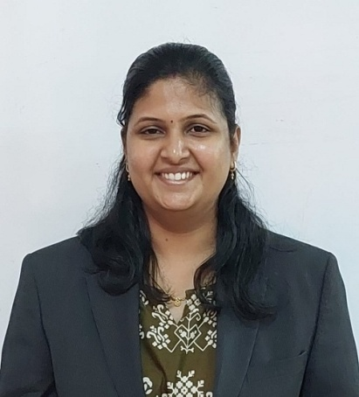
Ms. S. P. Nikam
It gives me an immense pleasure to release this News Letter for Department of Computer Engineering year 2022-2023 It’s an honor for me to highlight the achievement of department.
Student’s Editorial

It’s an honor for us to be the student editor of the Newsletter team. We takes this opportunity to thank committee members and all staff members of the department for their help & support in publishing this Newsletter.
Miss. Shravani Jagdale (TY CO)
Miss. Neha Talekar (TY CO)

OUrTOPPERS
Third Year Toppers
1) Mr.Patil Utkarsh R. (91.37%)
2) Mr.Shete Pranav S. (90.23 %)
3) Miss.Koli Aishwarya V. (86.66%)

Second Year Toppers
1)Mr. Sutar Pranav S. (93.53%)
2)Mr. Patil Aryan R. (91.60%)
3) Miss. Jadhav Tanuja T. (91.46%)

Events Organized

“CAREER DEVELOPMENT LECTURE”
Ashokrao Mane Polytechnic and Department of Computer Engineering, had organized expert lecture of “Career Development, after Diploma Engineering” dated on 19/03/2022.

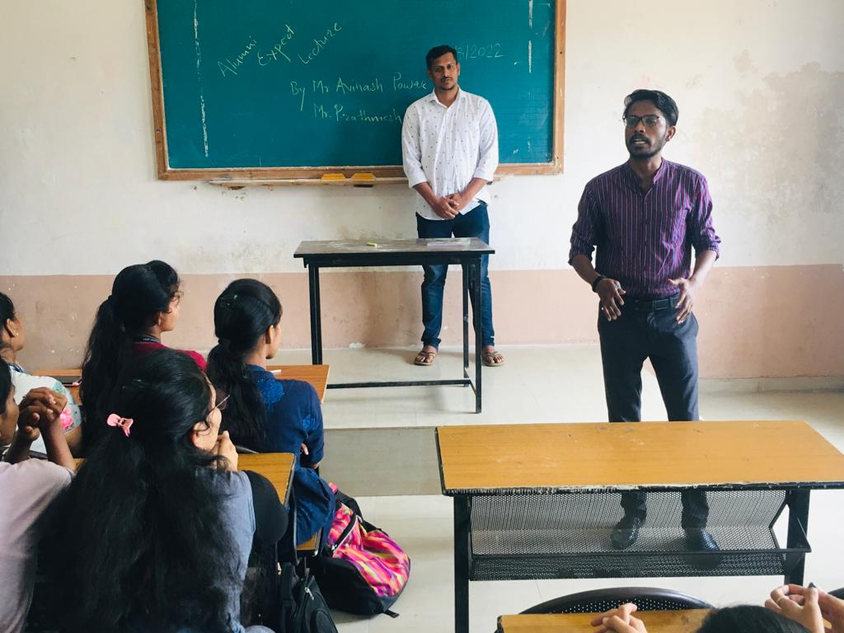

First, we inaugurated the program and done the felicitation of expert by HOD.
This expert lecture is delivered by Mr..A. S. Powar (Eagle Burgmaan Pvt. Ltd. Pune).
This expert lecture had organized according to curriculum of M.S.B.T.E. This expert lecture as very helpful to students to improve their knowledge about Career Development also important for their academic point of view. Students took participation very interestingly and made very good interaction with expert.
anyone’s life. The celebration marks lot of respect for the Gurus.

“PERSONALITY DEVELOPMENT LECTURES”

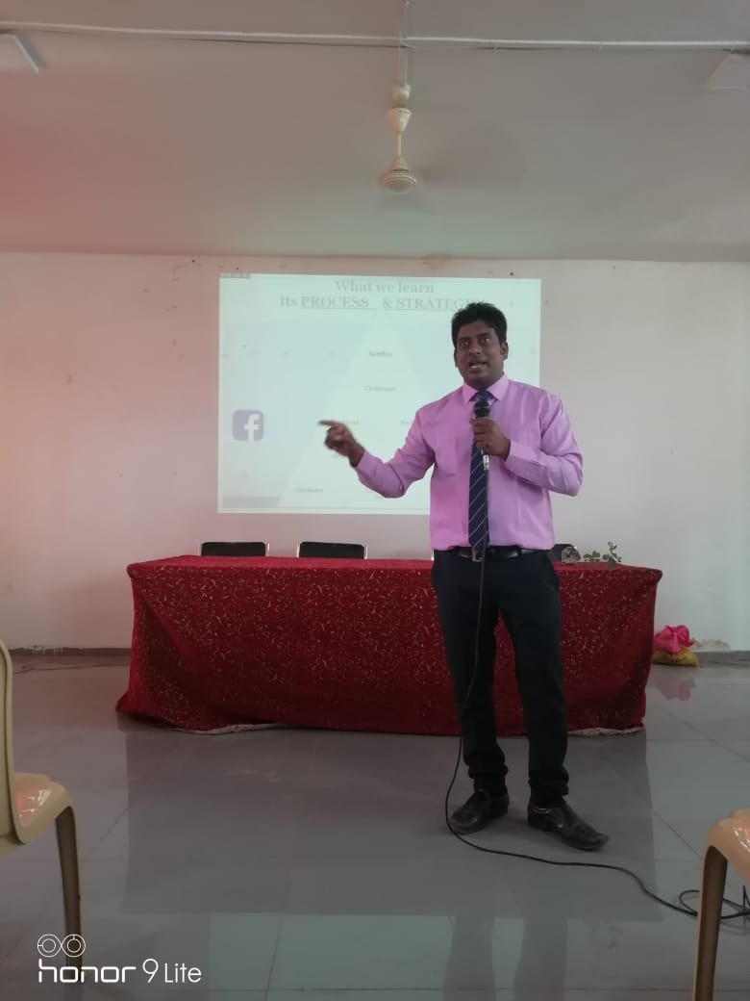
Ashokrao Mane Polytechnic and Department of Computer Engineering, had organized expert lecture of “Personality Development Lecture” on dated 02/08/2019. First, we inaugurated the program and done the felicitation of expert by HOD
Firstly, we inaugurated the program and done the felicitation of expert by HOD
This expert lecture is delivered by Dr..A. K. Maske Assistant Professor (MBA Dept). This expert lecture had organized according to curriculum of M.S.B.T.E. This expert lecture as very helpful to students to improve their knowledge about interview also important for their academic point of view. Students took participation very interestingly and made very good interaction with expert.

“PERSONALITY DEVELOPMENT LECTURES”
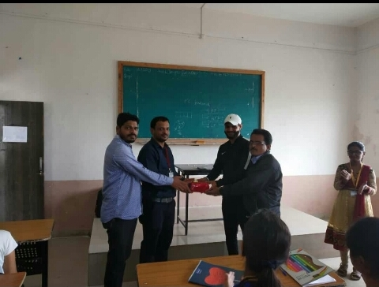
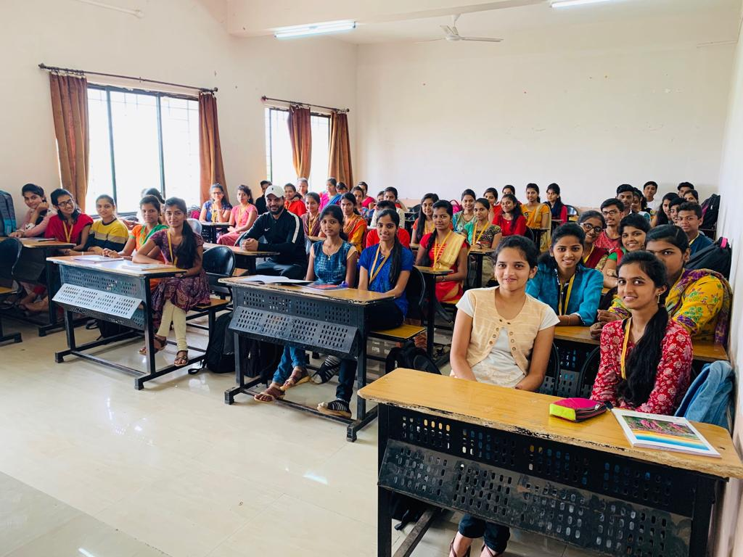
Ashokrao Mane Polytechnic and Department of Computer Engineering, had organized expert lecture of “Great ideas for Carrier” on 10/09/2019. First, we inaugurated the program and done the felicitation of expert by Mr. D. S.Barwade
This expert lecture is delivered by Mr Manjit Rajput This expert lecture had organized according to curriculum of M.S.B.T.E. This expert lecture as very helpful to students to improve their knowledge about interview also important for their academic point of view. Students took participation very interestingly and made very good interaction with expert.

“TECHNICAL EXPERT LECTURES”

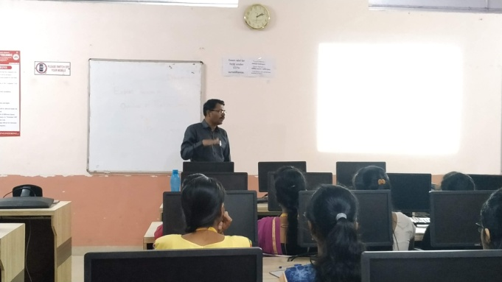
Ashokrao Mane Polytechnic and Department of Computer Engineering had organized expert lecture on “An overview of Machine Learning” on dated 30/09/2019 Firstly, we inaugurated the program and done the felicitation of expert by HOD. This expert lecture is delivered by Dr. Suhas Gajanan Sapate Dean, Research & Development Ashokrao Mane Group of Institutions, Vathar.
This expert lecture had organized according to curriculum of M.S.B.T.E. This expert lecture as very helpful to students to improve their knowledge about interview also important for their academic point of view students took participation very interestingly and made very good interaction with expert. We discussed various queries regarding “Machine Learning” and latest technology.

“Engineer’s Day”

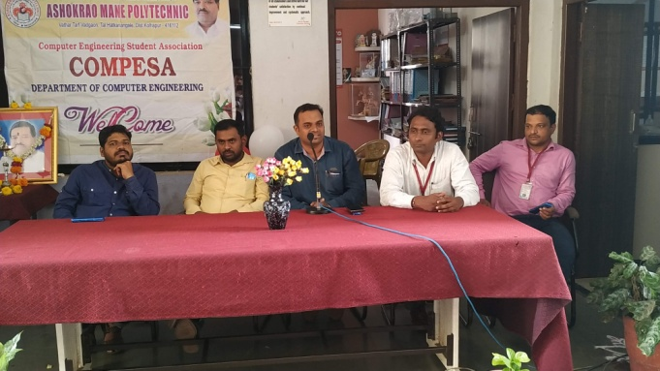
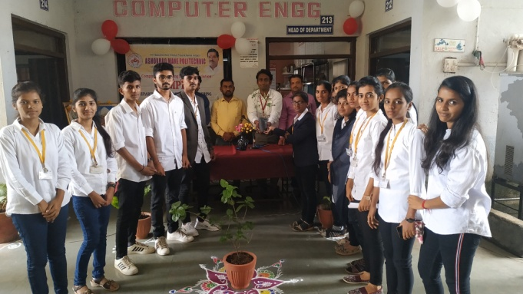

Ashokrao Mane Polytechnic and Department of Computer Engineering had organized Events of “Engineer’s Day” on 16/09/2019. First, we inaugurated their program and done the felicitation of Guest by Mr. S.A.Lakade (Head of Dept. of Computer Engineering) offering a memento as a token of love.
This Event is very helpful to students to improve their technical knowledge, also is important for their academic point of view. Students took participation very interestingly
M. Vishveshvaraya, KCIE (popularly known as Sir MV; 15 September 1861 – 12 April1962) was an Indian engineer, scholar, statesman and the Diwan of Mysore from 1912 to 1918. He is a recipient of the Indian Republic's highest honour, the Bharat Ratna, in 1955. He was knighted as a Knight Commander of the British Indian Empire (KCIE) by King George V for his contributions to the public good. Every year,on his birthday, 15 September is celebrated as Engineer's Day in India in his memory.

Industrial Visit
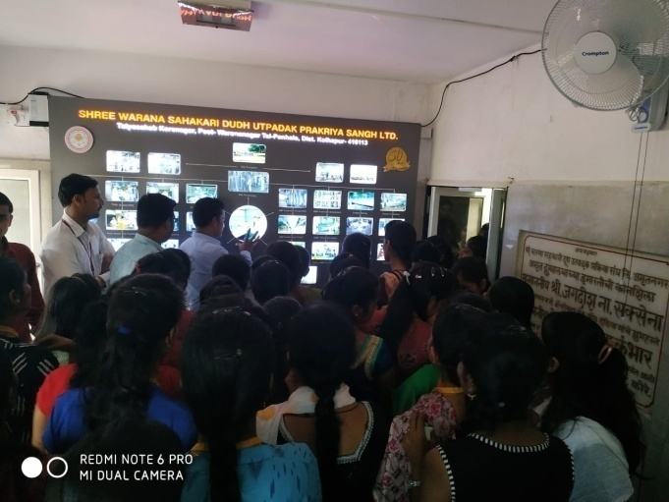

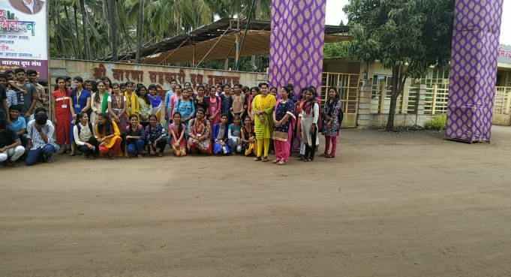

Our department has organized industrial visit to Shree Warana Sahakari Dudh utpadak sangh Ltd Amrutnagar for overall development of our students, which is also part of curriculum declared by MSBTE for subject ‘ERP Based Project Selection’ on 18/09/2019.This visit was very helpful to students to improve their knowledge about “Project Selection”. Also it is important for their academic point of view students took participation very interestingly and made very good interaction with expert. We discussed various quarries regarding ‘Project Selection’ and latest technology.

SOME OF GLIMSESS
