Shri Balasaheb Mane Shikshan Prasarak Mandal’s,
ASHOKRAO MANE POLYTECHNIC
Vathar Tarf Vadgaon, Tal. Hatkanangle, Dist. Kolhapur-416 112(Maharashtra)
Phone: Principal (0230) 2407740, Office: (0230) 2407760 Fax: (0230) 2407750
Website: amietv.org Email: ampolytechnic@amietv.org, ampolytechnicvathar@gmail.com
 | Department : Automobile Engineering | Rev. No. 0
 | Year : 2019-20 | Rev. Dt: 18/12/2012
 | Page: 1 of 1 | Audit No.:
 | Campus Selection 2019-20 Batch

Name of Student |  | Company Name
GHATAGE NILESH NANDKUMAR |  | John Deere
PATIL MANTHAN MOHAN | 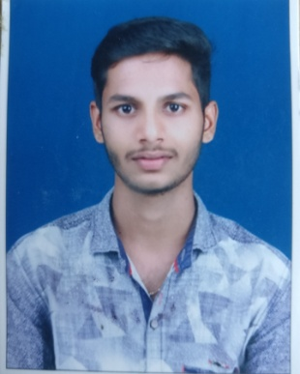 | Piaggio Vehicles,Baramati
PATIL SURAJ LAHU |  | John Deere
MAHADIK YUVRAJ VIJAY | 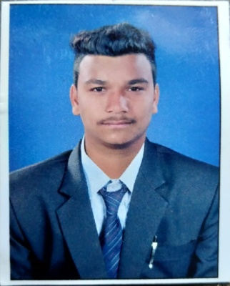 | Fukoku India Pvt Ltd
NAIK VISHAL ASHOK | 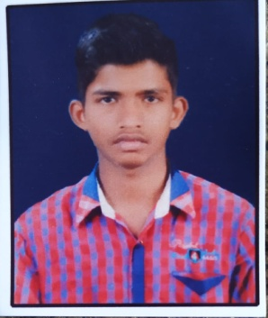 | Wave Suspension Ltd
SUTAR SHIVANI CHANDRAKANT | 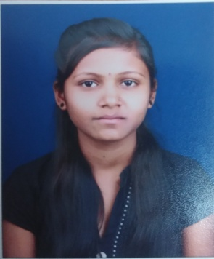 | Piaggio Vehicles,Baramati
KHOT PRATIKSHA YUVRAJ | 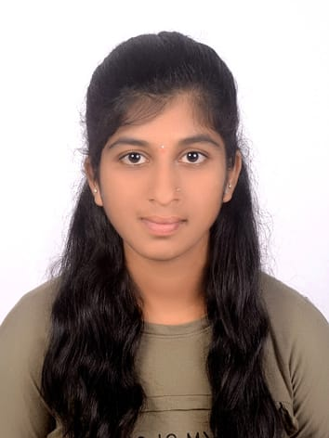 | John Deere
MASKAR SWAPNALI SANJAY | 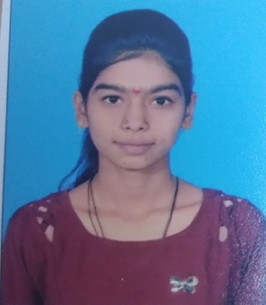 | Cummins India Pvt.Ltd.
BHANDARI SAURABH BHAUSO | 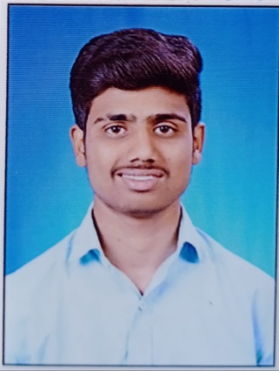 | Wave Suspension Ltd
KUKADE PRATIK SANDEEP | 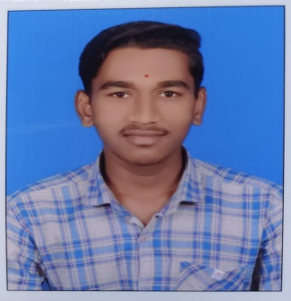 | Wave Suspension Ltd
PATIL VAIBHAV SITARAM | 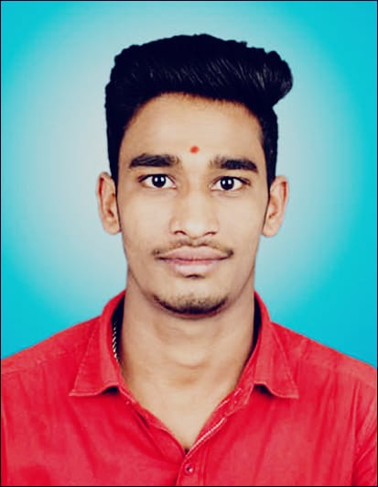 | Wave Suspension Ltd
HASBE SAKSHI PRADIP | 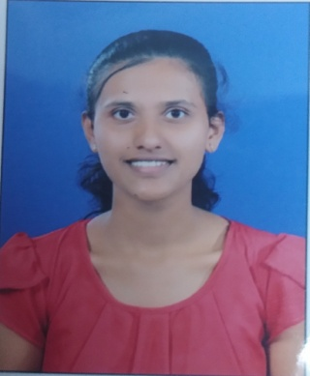 | Cummins India Pvt.Ltd.
GURAV PRITI RAJENDRA | 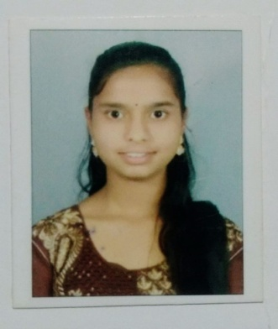 | John Deere
CHOUGALE RUPALI NARAYAN | 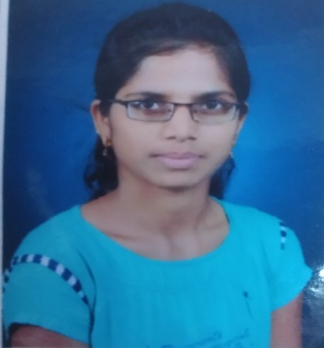 | Cummins India Pvt.Ltd.
SHAH ARMAN A MANNAN | 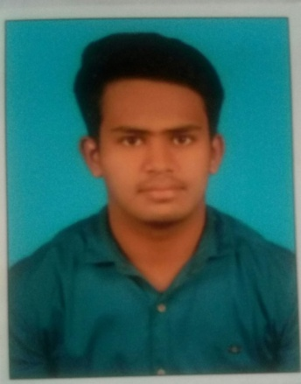 | Fukoku India Pvt Ltd
POWAR ANIKET RAJARAM | 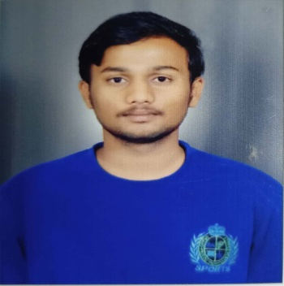 | John Deere
DIVTANKAR ABHISHEK ANANDA | 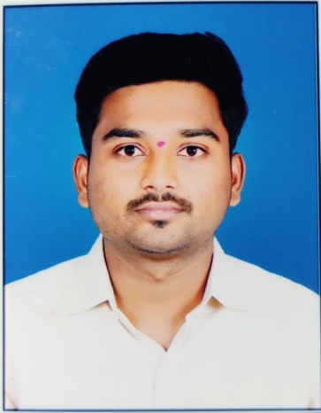 | Wave Suspension Ltd
SWAMI ANKUSH SUNIL | 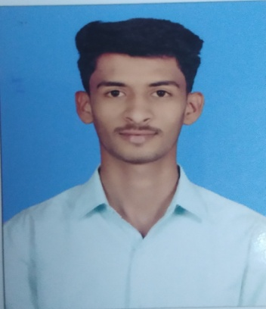 | Cummins India Pvt.Ltd.

