Shri.Balasaheb Mane ShikshanPrasarakMandal’s,
ASHOKRAO MANE POLYTECHNIC
VatharTarfVadgaon, Tal. Hatkanangle, Dist. Kolhapur-416 112(Maharashtra)
 | Department : Applied Science & Humanitics | Rev. No. 00
 | Year : 2020-2021 | Rev. Dt: 18/12/2012
 | Page : 1 of 1 | Audit No.:

Topper List with Photo Winter -2020
Rank |  | Name | % | Photo |  |  | Class
1st |  | Mr. Sutar Pranav Sandip | 97.43% | 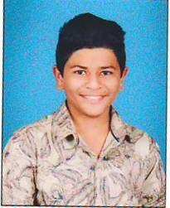 |  |  | FYCO
2nd |  | Mr.Patil Vishwajit Santosh | 95.29% | 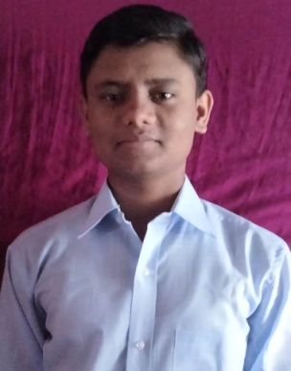 |  |  | FYCE
3rd |  | Mr. Mali Abhishek Pundalik | 94.86% | 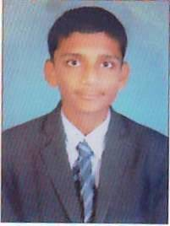 |  |  | FYCO
4th | Mr.Patil Sanket Mahableshwar |  | 94.57% |  | 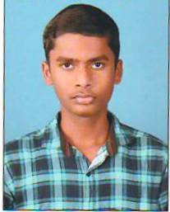 | FYME
5th | Mr.Maner Faijan Niyaj |  | 94.43% |  | 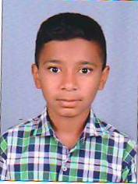 | FYEJ

